**WEB DEVELOPMENT**

**PRACTICAL 10,11,12**

**Name:** Vrishav Garg

**Roll No.:** 12111051

**Branch:** CSE

**PRACTICAL 10:**

**CODE:**

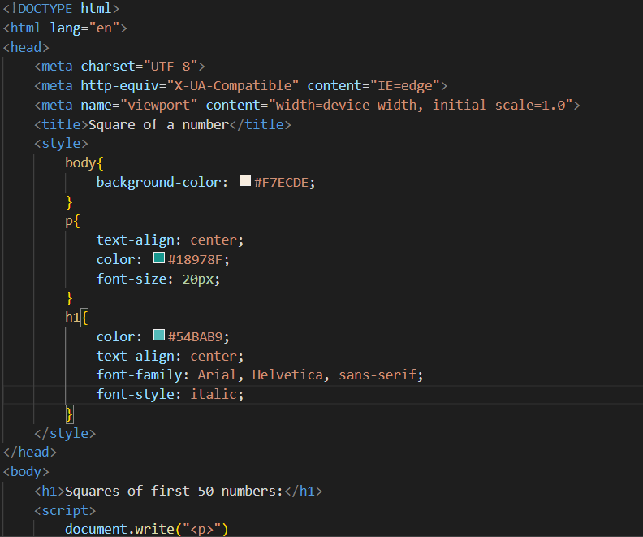

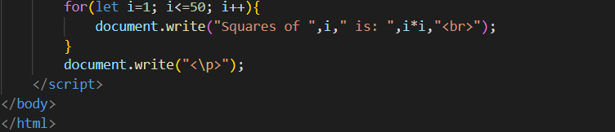

**Output:**

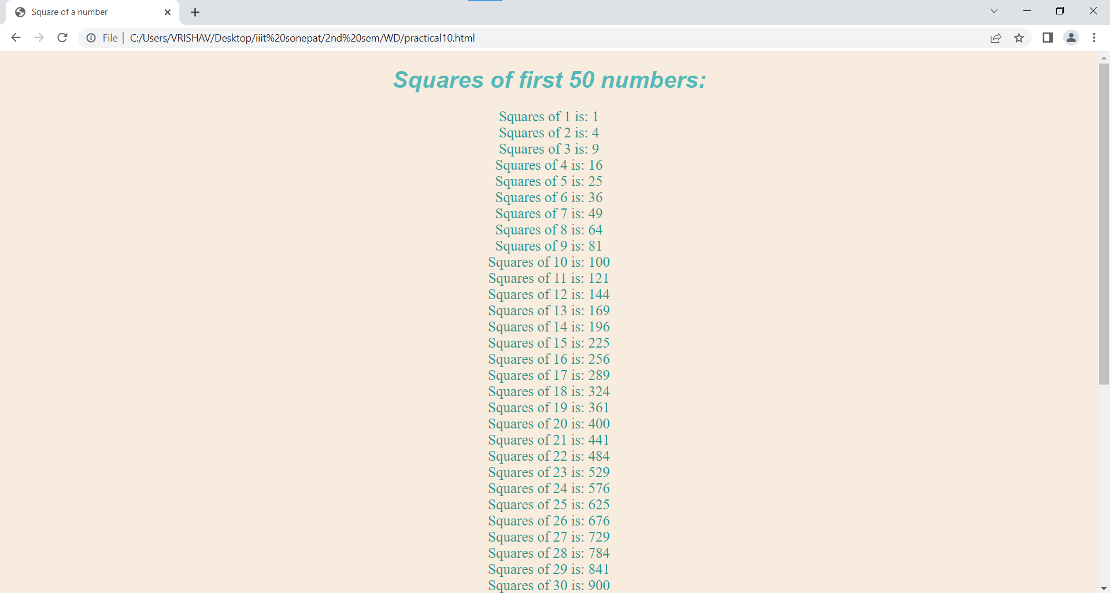



**Practical 11:**

**Code:**

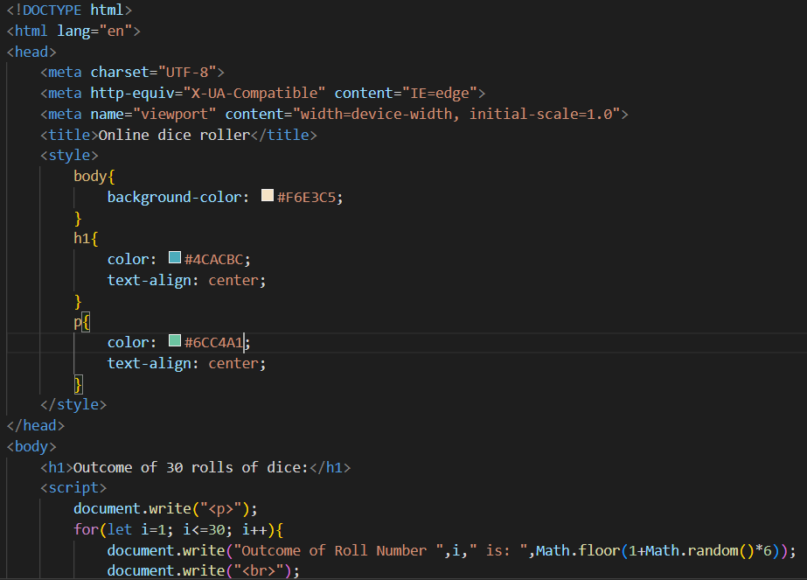

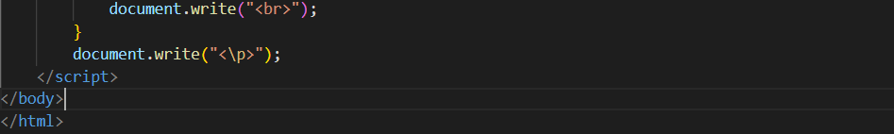

**Output:**

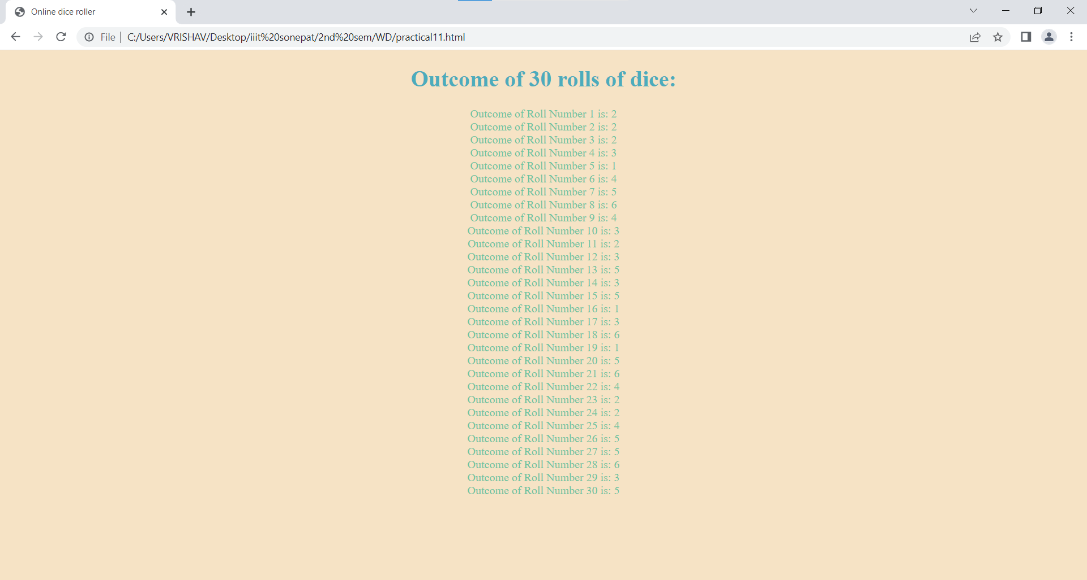

**Practical 12:**

**Code:**

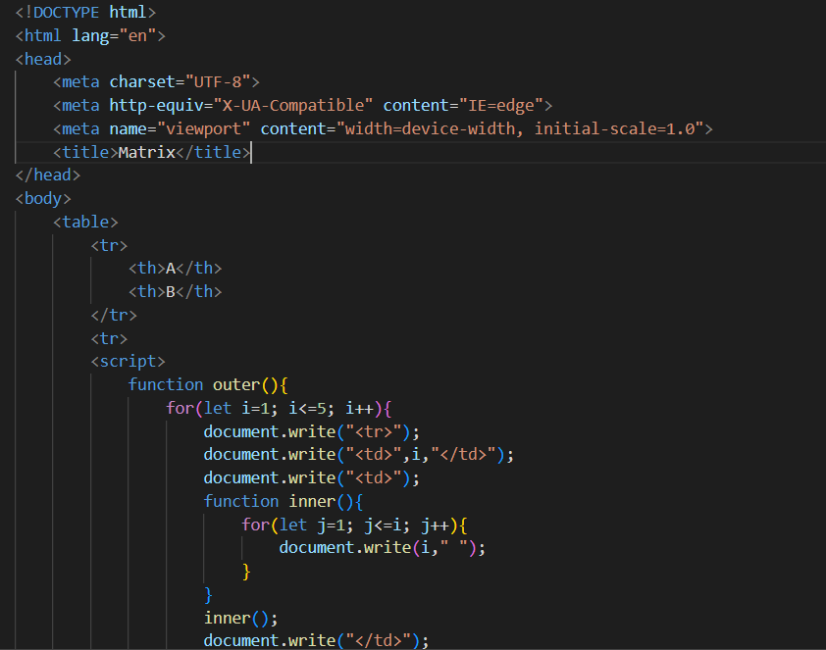

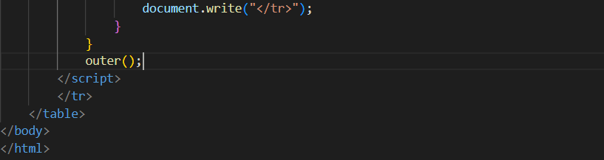

**Output:**

